REQUIREMENT ANALYSIS
TECHNOLOGY STACK( ARCHITECTURE AND STACK)

Date | 10 March 2026
Team ID | 69c0d687f58a227701cdf01d
Project Name | Streamlining Ticket Assignment for Efficient Supports Operations
Maximum Mark | 4 Marks

Technical architecture diagram:

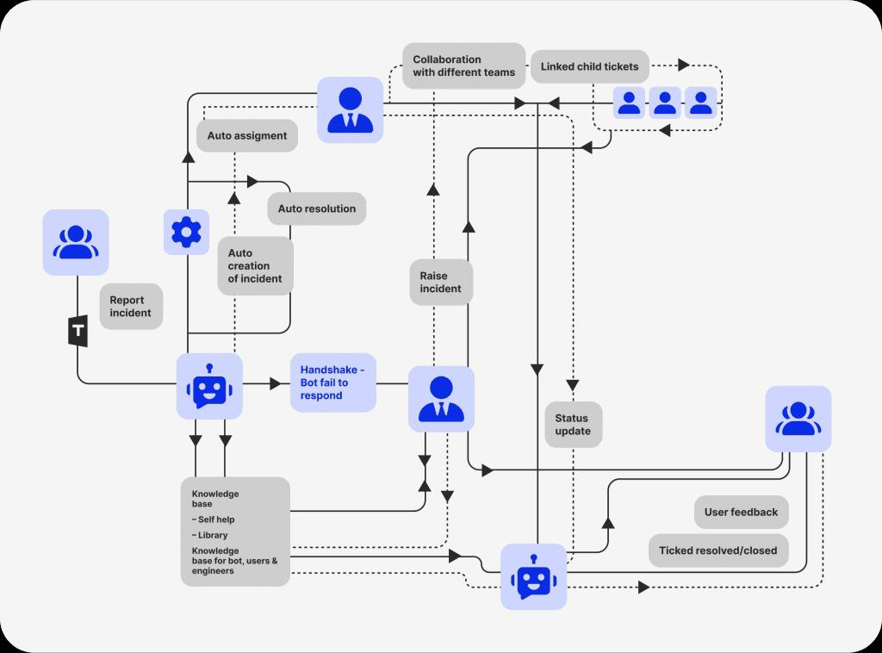

Table 1: Technical Architecture
S.no | Component | Description | Technology
1 | User interface | Interface for users (customers & support agents) to create, view, and manage tickets (Web/App/Chatbot) | HTML, CSS, JavaScript, React JS / Angular, Mobile Ap
2 | Application logic -1 | Ticket creation, categorization, and prioritization logic | Java / Python (Spring Boot / Django)
3 | Application logic-2 | Automated ticket assignment using rules (priority, availability, workload) | Python (Rule Engine), Node.js
4 | Application logic-3 | AI-based smart routing and chatbot interaction | IBM Watson Assistant / Dialogflow
5 | Database | Stores ticket data, user data, status, logs | MySQL / PostgreSQL / MongoDB
6 | Cloud Database | Cloud-based scalable database services | AWS RDS / Firebase / IBM Db2

Table 2:Application characteristics
S. no | Characteristics | Description | Technology
1 | Open-Source Frameworks | Frameworks used for development | React JS, Node.js, Django, Spring Boot
2 | Security Implementations | Authentication, authorization, data protection | OAuth 2.0, JWT, SSL/TLS Encryption, Firewalls
3 | Scalable Architecture | Microservices architecture for scaling ticket operations | Kubernetes, Docker, Microservices
4 | Availability | High availability using distributed systems | Load Balancer (NGINX), AWS ELB
5 | Performance | Optimized for high ticket volume and fast response | CDN, Caching (Redis), API Gateway

